**Instructions**

**To add Performance Data to a Program on the** [**Eligible Training Provider List**](https://joblink.maine.gov/training)

**Student performance data is required for program approval on the ETPL. Once you have entered your program information, the system will ask for student performance information.**

1. Log in to your ETPL account <https://joblink.maine.gov/training>

Go to your training institution’s account.

1. This is the next screen you should see after you update your program. Click **Add Performance**

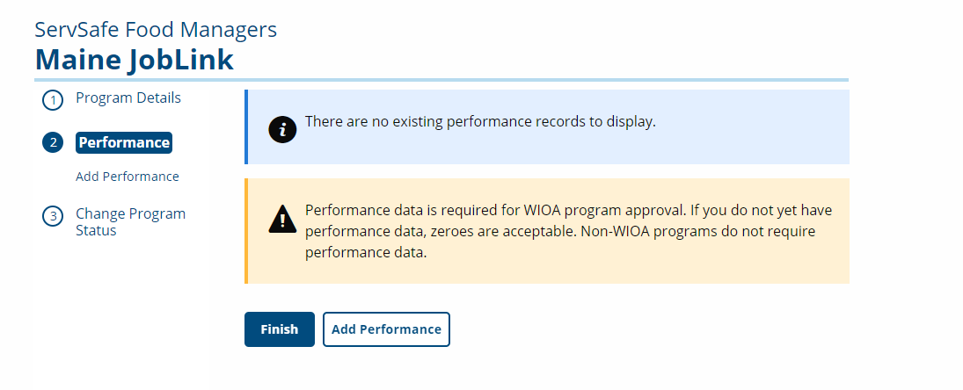

1. You should see this screen next.

**Student Type**: Select **WIOA to report only on WIOA supported students,** or **Overall** **to report on all the students**. Enter the numbers to the best of your ability. If the system won’t accept zero, then enter any number. I suggest 1.

All the fields have to have some value (number or date) in them.

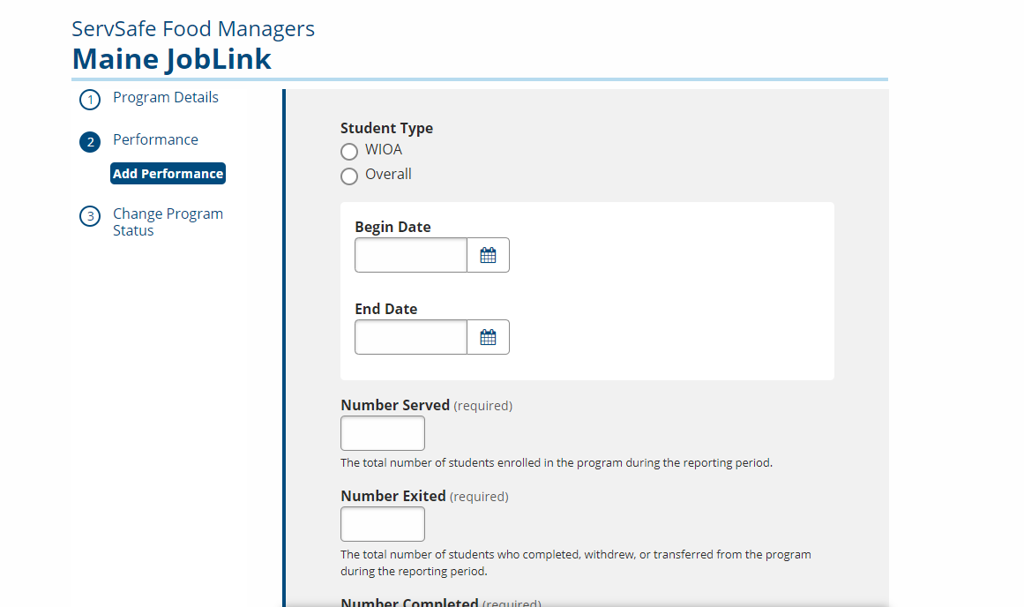

If you do not know the **Number of Students Employed**, you can enter 0.

**Number Who Attained Credential**: cannot be more than the number of students who attended the course.

When you get to the **Median Earnings** field, if you don’t know the students’ earnings, just leave it as .00

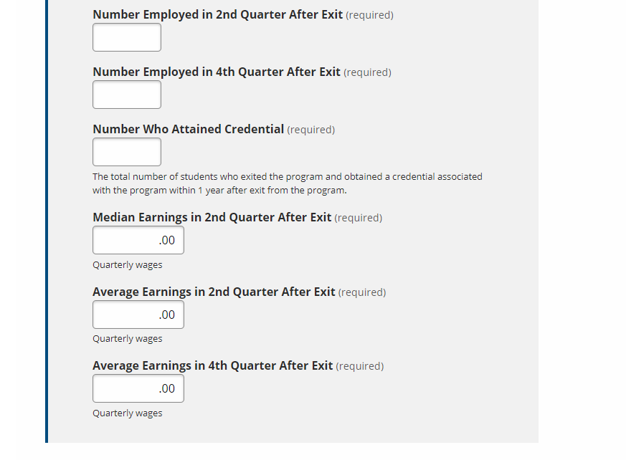

1. Once you have entered this information, hit **Save** to continue. You will see this next:

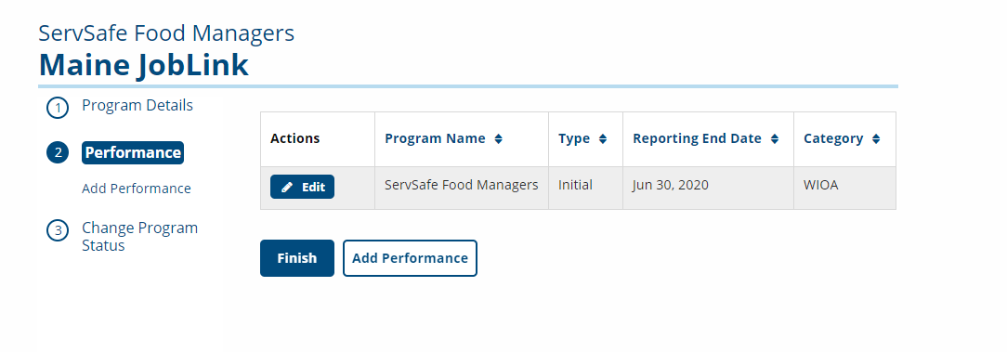

1. Select Finish. You are done.

Once performance data is provided, the program can be reviewed for approval.